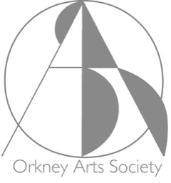
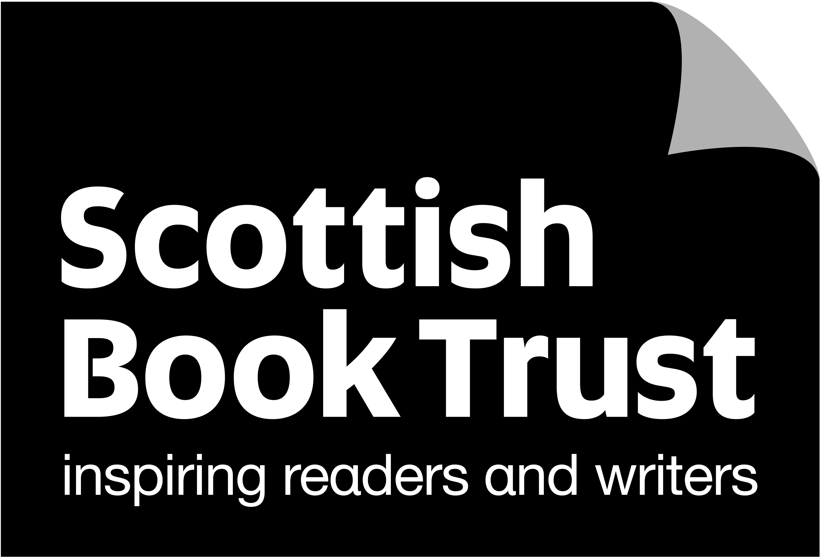
Orkney Arts Society
presents

“Memories
from a forgotten country”
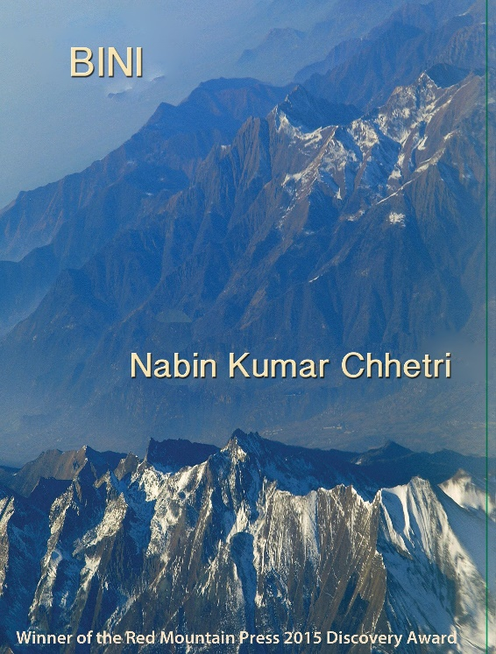
Scottish-Nepalese poet and writer
Nabin Chhetri
will read from his poetry collections and prose

Stromness Town Hall

Tuesday 14 March 2023, 7.30pm

Tickets: £5 non-members, £4 members, £1 children
Bookings from https://www.ticketsource.co.uk/orkney-arts-society

